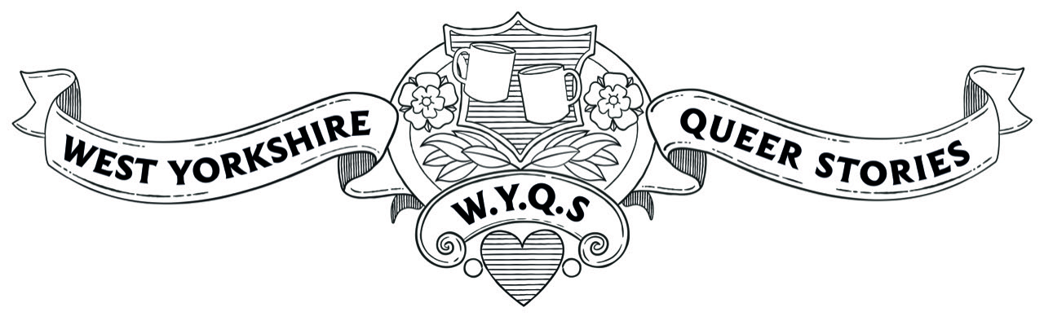Thank you for your interest in being a volunteer for the WYQS project. Please could you complete the form below.
Name
Email/
phone number
Postcode
How would you describe your…?

Gender __________ Sexuality _______________ Ethnicity__________________

Do you have a disability? Yes (Please give details) No

Which age bracket applies to you?: Under 18 19-30 31-54 55+

Do you have a particular interest you’d like to explore? (e.g. trans lives, the history of Leeds Pride, growing up gay in Bradford)

Tick the role(s) that interest you:
Community Curator
Transcriber
Researcher
Events Volunteer

